
NCICB

C3D Connector 1.5 Software Architecture Guide

Version No: 1.0
Last Modified: 05/05/2008

Author: Patrick Conrad
Team: C3D
Client: National Cancer Institute - Center for Bioinformatics,
National Institutes of Health,
US Department of Health and Human Services

Document History

Document Location
The most current version of this document is located on the C3D Tools GForge Site:
none yet

Revision History
Version Number | Revision Date | Author | Summary of Changes
1.0 | 05/05/2008 | Patrick Conrad | Initial Draft

Review
Name | Team/Role | Version | Date Reviewed | Reviewer Comments

Related Documents
More information can be found in the following related documents:

Document Name

Table of Contents
Document History 2
Document Location 2
Revision History 2
Review 2
Related Documents 2
Table of Contents 3
Table of Figures 4
1. Introduction 5
1.1 Purpose of this Document 5
1.2 Methodologies, Tools and Techniques 5
1.3 Key Stakeholders 5
1.4 Points of Contact 5
2. Technical Overview 6
2.1 Background Information 6
2.1.1 BRIDG 2.0 6
2.1.2 EnrollPatient 6
2.1.3 GetCDEs 6
2.1.3 GetCDEData 6
2.1.4 CCTS Efforts 6
2.1.4 Risks 7
2.1.5 Assumptions 7
2.1.6 Dependencies 7
3. System Architecture 8
3.1 Architectural Goals 8
3.2 Architectural Tiers 8
4. Software Internals 9
4.1 Workflow Plug-in Tab 9
4.2 Workflow Panel 10
4.3 Workflow Object Layer 10
4.4 Semantic Wiki Integration 11
Deployment 12
Deployment Diagram 13
Deployment Products and Framework Versions 13
Appendix 1 – Sample RDF from Wiki 15

Table of Figures

Figure 4 – Workflow Assignment Table 9
Figure 5 – Workflow Editing Panel 10
Figure 6 – Protégé to SMW Communication 11
Figure 7 – Sample RDF from Wiki 15

- Introduction
The CDMS Connector, previously know as the C3D Connector, provides a means by which external applications can interact programmatically with the C3D Clinical Database. The CDMS Connector originally provided a means for acquiring patient positions on studies and loading a minimal amount patient related dated during the enrollment. The CDMS Connector also provides a means for loading patient laboratory test results into the electronic case report forms or panels of C3D Studies. In the newest release of the Connecter, the name of the service has been altered to reflect the changed from the single destination point of C3D to multiple destination points for clinical database management systems being introduced. Additionally, outbound data services are also being introduced in this release.

To briefly summarize, the main goals of the 1.5 release of this project are:

- The C3D Connector becomes the CDMS Connector with the C3D destination become an adapter of the service. Allows other database systems to become adapters as well.

- Enhance the C3D patient enrollment service to allow additional data to be passed into C3D, in a configurable manner.

- Re-factoring of code base to adopt the BRIDG 2.0 data model.

- Introduce basic data retrieval from the C3D database using CDE identifiers of caDSR.

- Introduce retrieval of CDE identifiers at the study level from the C3D database.

- Introduce security levels to safeguard the movement of data in and out of the C3D service adapters.

1.1 Purpose of this Document
The main purpose of this document is to provide a high level design and architectural description of the new capabilities in the 1.5 release of the C3D Connector.

1.2 Methodologies, Tools and Techniques
Part of the development tasks are being done in Java primarily using Eclipse as the Integrated Development Environment (IDE). Ant is used for daily building of the code, unit testing, and Javadoc generation. The project artifacts are being tracked in GForge.
More development work is being done in the C/C++ realm primarily using Visual C++ as the Integrated Development Environment. The method is used due to the underlying API structure used by Oracle Clinical. The project artifacts for this development effort are also being tracked in GForge.
Finally, as C3D is Oracle based, query development tasks are being done with SQL and PL/SQL, using the Oracle 9i PL/SQL engine. T.O.A.D. and SQL/Plus are also being used in the development and testing phases of the database query code. Artifacts from this effort are also being tracked in GForge.

1.3 Key Stakeholders
Name | Description | Responsibilities
Christo Andoyadis | C3D Product Manager | Directs C3D Projects
Charles Griffin | C3D Project Manager | Project Management

1.4 Points of Contact
- Project Oversight/Management
- Technical Overview

2.1 Background Information
The CDMS Connector was originally designed as a proof of concept, showing that a Java based service could be created that would interact with the C3D environment. The early proof of concept bypassed the API functionality provided with C3D and worked directly with the underlying objects of the database. The next iteration of the service was reworked so that the API functions would be used instead.

As the CDMS Connect is a Grid Service, it does not have a user interface of its own. It relies on other external systems to invoke it and provides its output through normal Java messaging services.

The 1.5 version of CDMS Connector will enhance one existing component while introducing three new components. The following sections will describe those components.

2.1.1 BRIDG 2.0
Along with the name change, the CDMS Connector Release 1.5 is being refactored to use the BRIDG 2.0 model. The previous release of the Connector used the BRIDG 1.0 model. The refactoring will effect every service of the Connector.

2.1.2 EnrollPatient
The EnrollPatient component is being enhanced in several ways. The primary enhancement involves allowing more data elements to be passed to C3D during the enrollment process. Along with the current data values for enroll date and patient initials, the enhancement allows for patient birth date and gender as well as patient first and last names. To provide a more robust user option with this enhancement, the service is being additionally modified such that each the data values mentioned are loaded based upon a set of configurable controls. The service will only load those data items into C3D that the user has configured to do so. The configuration of this service will be kept external to the service itself in a java parameters file.

2.1.3 GetCDEs
The first of the new services being introduced in Release 1.5 is GetCDEs. This service will provide to the requestor, a list of each of the CDEs (Common Data Elements) used to build the requested study. Along with the CDE value and version, the response with include the following context information related to the CDE:
- DCI, DCM and Event name
- Question Name, Prompt and CDE values.
This service can be used to identify the caDSR elements used to the data panels of C3D, and can be used in the other service provided with this release.

2.1.3 GetCDEData
The next new services being introduced in Release 1.5 is GetCDEData. This service will provide to the requestor all data collected within the requested study relating to the requested CDE and version. Along with the data values, the requester will also receive the following context information:
- DCI, DCM and Event name.
- DCI and DCM date.
- Patient position.
- Question Group Name.
- Question Name, Prompt and CDE Value.

2.1.4 CCTS Efforts
Concurrently with the ongoing development efforts of Release 1.5 are the efforts to maintain, test deploy, document and demonstrate the C3D Connector Release 1.0 as a component of the CCTS tier. These efforts can at times interfere with the schedule within the realm of Workflow and WIKI Integration efforts is an ongoing maintenance effort of the existing code in order to make it more amenable to change and to position the code for an eventual migration to Protégé 4.0. We are currently working against Protégé v3.2 customized for NCI, though it is planned to merge this branch back into the trunk on for the 1.3.x releases. Although this code is currently in production use on a daily basis there is a substantial list of bugs that need to be addressed. Most have workarounds and many are only usability issues but the ability to address them in a timely fashion is impaired by the current state of the code. Thus all the new development work not only must adhere to best practices but must take into account the needs of re-factoring the current code and integrating the new components in such a way as to not make matters worse.

2.1.4 Risks
2.1.4.1 Code Complexity
Due to the nature of the Grid being Java based, and the application interfaces of C3D being C based, introduces a complexity between the interchange of data and use of libraries between the two programming school. Also inherent in the application interfaces of C3D is the need for the pre-compilation of the C/C++ code via Oracle’s Proc*C compiler. To reduce this dependency, SQL and PL/SQL coding and queries will be limited to as few C++ programs as possible. As SQL and PL/SQL can be readily used within Java, this will be emphasized.

2.1.4.3 Testing
We are using junit tests as much as possible for all work involving data and object layers, and wherever possible we are using them on the existing code. Due to the nature of the registration process within C3D, we will be investigating the ability to “remove” registrations to create a cleanup operation. In the future, a regression test suite will help with QA, though it will not replace unit and usability testing.

2.1.5 Assumptions
We have to assume that the C3D API elements (DLLs) that we depend on will remain as the standard external access points to C3D, and that any changes to these underlying elements are well document and tested by the providing vendor.

2.1.6 Dependencies
The 1.5 release is dependent on the C3D APIs. Any changes to these elements would require a new release of the C3D adaptors. The C3D APIs themselves have a dependency on the Oracle Client version as well, which is currently the v8.0.6 release. The Oracle 8.0.6 has a dependency on its operating system, which is certified as Windows 2003 (32 Bit) Service Pack 2.
- System Architecture

3.1 Architectural Goals

3.2 Architectural Tiers

- Software Internals

As mentioned above, the Workflow capabilities introduced in the 1.2.1 release completely leverage the existing infrastructure that exists in Protege, with the exception of the component that communicates with the WIKI. There are three major pieces:

4.1 Workflow Plug-in Tab

This is the main GUI component of workflow. Implemented as a Protege plug-in, it presents an excel-style table of the assignments. Each row in the table is an assignment. The columns contain fields like the date it was created and last updates, the manager who created the assignment and the modeler it was assigned to. When a Protege user logs in, her role as either manager or modeler determines the features enabled or not in the Workflow plug-in. For example only managers can create new assignments or add new users.

Figure 1 – Workflow Assignment Table
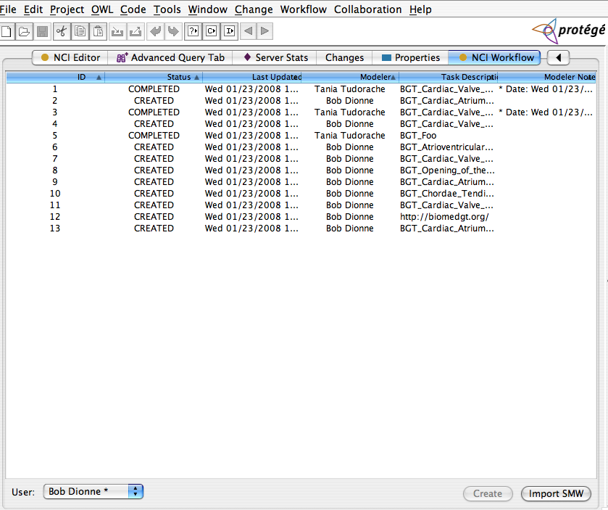

4.2 Workflow Panel
When a modeler or manager edits an assignment, the RDF packet stored in the assignment is parsed, an OWL class is created and a workflow edit panel is brought up that allows editing of the assignment. This panel is largely the same look and feel as the existing clone panel. It presents two tree panels, the top with the proposed concept and the bottom with the existing concept. Based on the proposal, the editor makes changes to the existing concept and saves it.

Figure 2 – Workflow Editing Panel
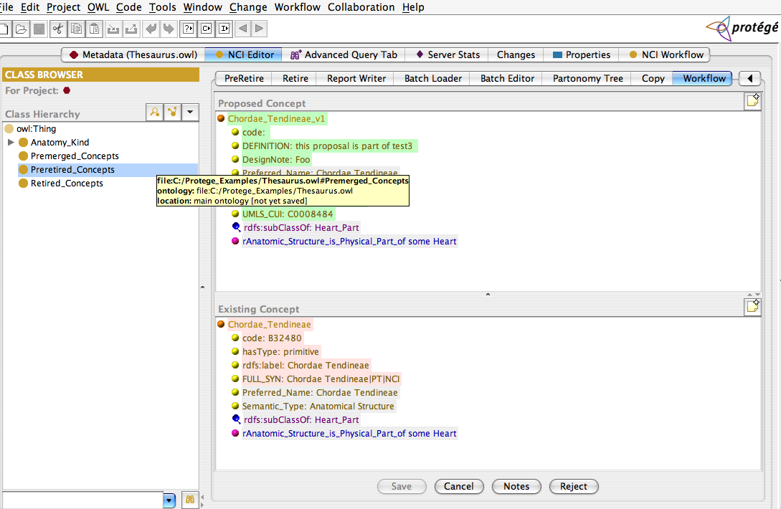

4.3 Workflow Object Layer

This object layer provides API access to the workflow store (figure 3 above). There are objects like Assignment and User that are managed by a Workflow object. A listener capability enables support for the Workflow plug-in to listen for events when assignments are updated or new ones created. This layer interacts with the server using Protege’s ProtegeJob object, which provides an architected access to the RMI services. The semantics of the ProtegeJob object are simple enough that a simple wrapper enables the storage layer code to be tested locally first before remoting it to the server. In the future if the need arises for a distributed model that involves local persistence we will be able to readily rework the code to support that.

4.4 Semantic Wiki Integration

This component is actually two distinct and orthogonal packages. The first handles communication with the WIKI. It’s responsible for establishing the connection to the WIKI and retrieving RDF from the pages. It’s built using the Java WIKI Bot Framework, an open source product which provides a layer on top of the Apache HTTPClient project. This is a small amount of code and not very well written and/or documented but it enabled us to get something up and running in order to work out this communication. This will be either cleaned up or replace with a more rigorous use of HTTP Client.

The second component handles parsing the RDF into OWL classes for use in Protégé. Some of the names use by the WIKI need to be mapped to different names in Protege, some of the classes are new and need codes, and so forth. As this layer is driven by users editing assignments in the Workflow plug-in, it caches the processing of the RDF for better performance. Figure 6 provides a high level view of these classes.

Figure 3 – Protégé to SMW Communication
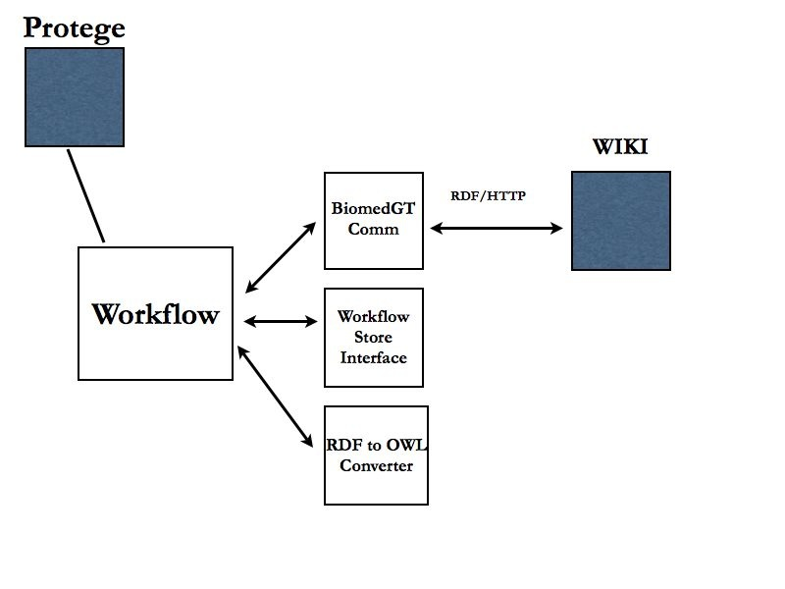

Deployment

Generally this release uses the existing build and packaging scripts of Protege. Our NCI Protege project has a master build script that is responsible for building both the client and server components. The result is a client side install package that is published in GForge for users to download. The server side is somewhat more complicated. The basic idea is that each plug-in is built as a jar file that is installed in a dedicated place that Protege uses to load them at initialization. Protege also makes use of a metaproject file that is used for access control and to store information about specific projects. This can edited as a file project in Protégé, which allows for easy maintenance.

Depending on whether or not a new database of content is being creating, the server install might run a target that configures a new project and builds the database, or it might just copy existing metaproject files over to a new location to use with an existing database. The master Ant build script also produces the needed shell scripts to start the servers.

The workflow store can initialize itself from scratch, but once a working store is in use, it will need to be backed up and maintained similar to the database. As workflow evolves we imagine some sort of archiving will be necessary to deal with older assignments.

Component Name | Third Party Jar
XML Pull Parser | xpp3-1.1.4.c.jar
Java Media WIKI Bot | jwbf-1200rc3.jar

Suggested arrangement for this section…..

Deployment Diagram
NCI BioPortal will deploy using Ant. A customizable Ant script will be created which will allow for the application to be built and deployed to the NCICB QA, STAGING and PRODUCTION Servers.

- bioportal.jar – All general NCI BioPortal application logic non-specific to an business tier is contained in the app jar.
- bioportal.war – Contains the NCI BioPortal web application-specific components and web server classes.
- third party jars – All third-party jars used by the application.
- 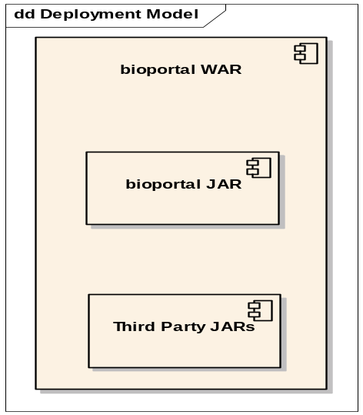

Deployment Products and Framework Versions
NCI BioPortal implements the following APIs and versions. As new versions are released or are supported by NCICB, the products will be updated after a determination that the versions do not cause problems in the application.

Name | Version | Provider | Description
Java SDK | 1.5.x | Sun Microsystems | JDK that the application runs. Deployed version dependent on NCICB standard at time of deployment. (java.sun.com/j2se/1.5/index.html)
Ant | 1.6.2 |  | The Build Scripting Tool.
JBoss | 4.0.4 | JBoss Group open source | J2EE application server. (www.jboss.org)
Tomcat | 5.1.28 | Apache open source | J2EE web container that ships integrated with JBoss. (jakarta.apache.org/tomcat)
JSF (MyFaces) | 1.1 | Apache open source | Web application framework (myfaces.apache.org/)
Commons | various | Apache open source | Common utilities required by JSF and utilized by NCI BioPortal. Includes: beanutils, collections, digester, logging
JDBC |  | MySQL | All Java driver for MySQL database
Log4J | 1.2.7 | Apache open source | Logging API. Also used by JBoss

Appendix 1 – Sample RDF from Wiki

Figure 4 – Sample RDF from Wiki
